

PERTH COLLEGE

CALCULUS

TRIAL TERTIARY ENTRANCE EXAMINATION 2007

STUDENT NUMBER:

In figures

In words

TIME ALLOWED FOR THIS PAPER:
Reading time before commencing work: Ten minutes
Working time for paper: Three hours

MATERIAL REQUIRED/RECOMMENDED FOR THIS PAPER

TO BE PROVIDED BY THE SCHOOL:
This Question/Answer Booklet comprising 21 questions and 28 pages.

TO BE PROVIDED BY THE CANDIDATE:
Leave out
Calc & notes free
Calc & notes allowed
MAT not MAS
Standard Items:

Pens, pencils, eraser or correction fluid, ruler.

Special Items:

Curriculum Council/SEA Mathematical Formulae and Statistical Tables Book, drawing instruments, templates and calculators satisfying the conditions set by the Curriculum Council.

NOTE: Personal copies of the Tables Book should not contain any handwritten or typewritten notes, symbols, signs, formulae or any other marks (including underlining and highlighting), except the name and address of the candidate, and may be inspected during the examination.

Four pages (two A4 sheets, both sides) of notes.

NOTE: These may be from any source, handwritten or typed. They must be brought into the examination room unfolded and left on the desk at all times. These pages will not be collected and no answers should therefore be written on them. Calculator manuals are not permitted in the examination room.

Important note to candidates
No other items may be taken into the examination room. It is your responsibility to ensure that you do not have any unauthorised notes or other items of a non-personal nature in the examination room. If you have any unauthorised material with you, hand it to the supervisor before reading any further.

Structure of this paper

QUESTION | MARKS AVAILABLE
1 | 6
2 | 10
3 | 4
4 | 6
5 | 9
6 | 13
7 | 8
8 | 9
9 | 15
10 | 7
11 | 8
12 | 6
13 | 11
14 | 6
15 | 9
16 | 6
17 | 5
18 | 8
19 | 7
20 | 13
21 | 14
Total Marks | 180

Instructions to candidates

1. All questions should be attempted.

2. Write your answers in the spaces provided in this Question/Answer Booklet. A spare answer page may be found at the end of this booklet. If you need to use it, indicate in the original answer space where the answer is continued (i.e. give the page number).

3. Show all your working clearly. Your working should be in sufficient detail to allow your answers to be checked readily and for marks to be awarded for reasoning. Incorrect answers given without supporting reasoning cannot be allocated any marks. If you repeat an answer to any question, ensure that you cancel the answers you do not wish to have marked.

4. It is recommended that you do not use pencil except in diagrams.
Question 1. [6 marks]

The function 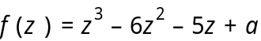 has a factor of 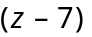.

(a) Determine the value of a.
[2]

(b) Find the exact value of all of the roots of 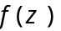.
[4]
Question 2. [10 marks]

Find 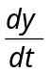 . Only minor simplification is required.

(a) 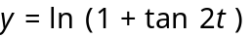
[2]

(b) 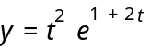
[2]

(c) y = 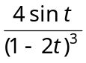
[3]

(d) y = 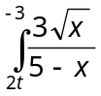 dx
[3]

Question 3. [4 marks]

Given that u = a + bi , v = b + ai where a and b are real integers, find all possible values of a and b given that:
u × v = 13i .
Show clearly how you obtained your answer.

Question 4. [6 marks]

A complex number z is defined such that z = 1 + cis , −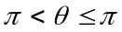.

(a) Determine Re(z) and Im(z), in terms of .
[2]

(b) Hence, if = 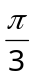, find exact values for |z| and arg(z).
[4]

Question 5. [9 marks]

A curve is defined implicitly by the equation 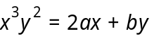 where a and b are both constants.

(a) Given that the curve has a stationary point at (-1, 2), determine the values of a and b.
[6]

(b) By calculating a suitable number of points, or otherwise, sketch the graph of the curve for 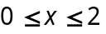 and 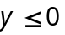.
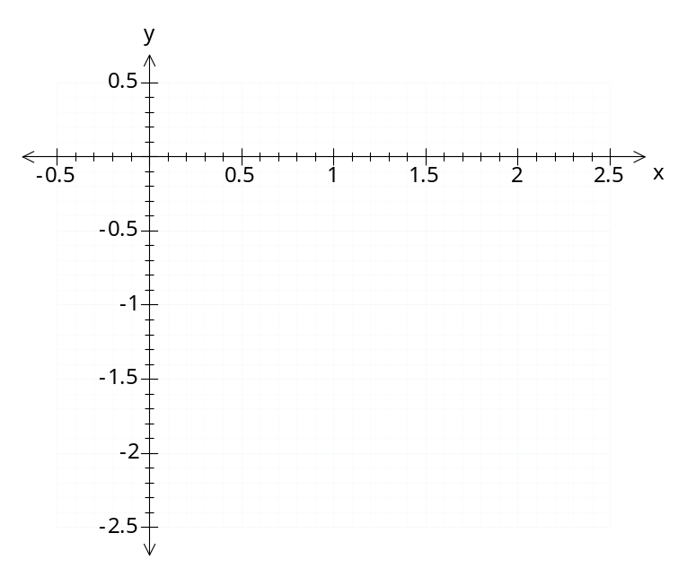[3]

Question 6. [13 marks]

(a) Evaluate the following limits exactly, where they exist. Show sufficient working to justify your answers.

(i) 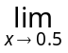 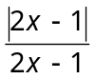
[2]

(ii) 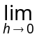 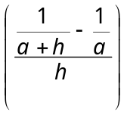 where 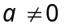
[3]

(iii) 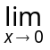 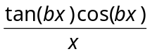
[2]

(b) The function k is defined as 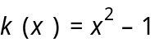 and the function 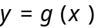 is shown in
the diagram below.
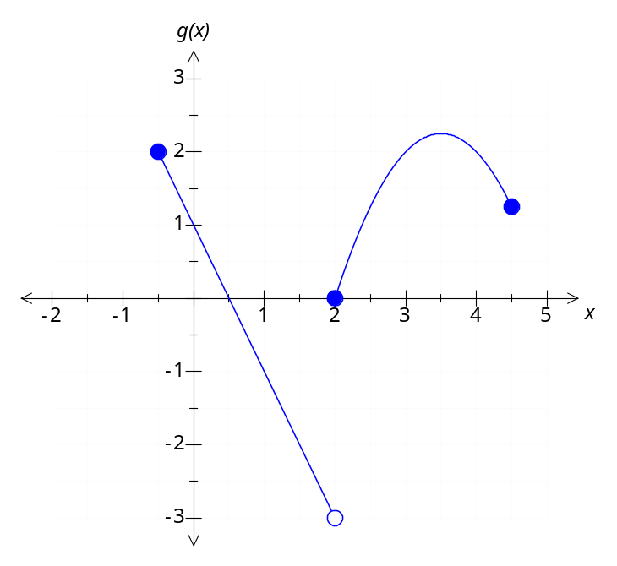

Evaluate the following limits.

(i) 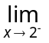 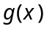
[1]

(ii) 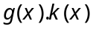
[1]

(iii) 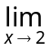 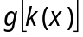
[2]

(iv) 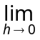 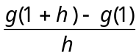
[2]

Question 7. [8 marks]

Consider the rational function, 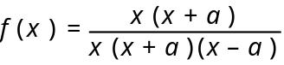 where 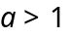.

(a) Find the equation of the horizontal asymptote(s) of 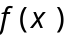.
[1]

(b) Find all values of x for which is not defined.
[2]

(c) Find the limit of as x approaches 0.
[2]

(d) For a = 2, sketch the graph of . Indicate all essential features of this graph.
[3]
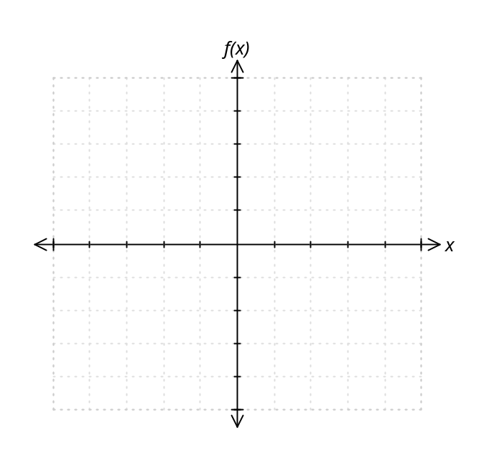

Question 8. [9 marks]

If z = −1 − i
(a) Simplify 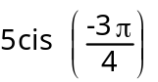× z and give your answer in exact polar form.
[3]

(b) Simplify 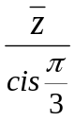 and give your answer in exact polar form.
[2]

(c) Find all complex numbers, w, where w³ = (–4 – 4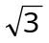i ).
Show clearly how you obtained your answers and give your answers in polar form.
[4]
Question 9. [15 marks]

(a) Determine the following indefinite integrals.

(i) 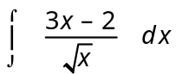
[2]

(ii) 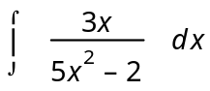
[2]

(iii) 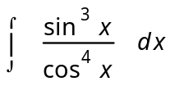 Let
[4]

(b) Use the substitution x = tan to show that 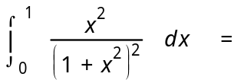 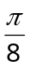 – .
[7]

Question 10. [7 marks]


Lizzie is riding her motorcycle along a straight country road. Three signposts A, B and C are evenly spaced along the side of this road
such that AB = BC = 90 metres. It takes Lizzie 6 seconds to travel
between A and B and 4 seconds to travel between B and C.

Assuming she is travelling with constant acceleration, use Calculus techniques to determine Lizzie’s displacement from A as a function of time and hence her constant acceleration.

Question 11. [8 marks]

(a) The equation of motion of a body is given by 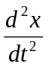 + 16x = 0, where x is the
displacement of the body (in cm) from a fixed point O at time t seconds. It is known that the body starts moving from O with a velocity of −1 cm s⁻¹.
Express the displacement as a function of time.
[5]

(b) The equation of motion of another body is given by x = 2 cos (0.5 t ) cm. Find the average speed of the body in the first ten seconds. Show clearly how you obtained your answer.
[3]

Question 12. [6 marks]

(a) On the diagram below, sketch the locus of the point z where z + = 6.
[2]
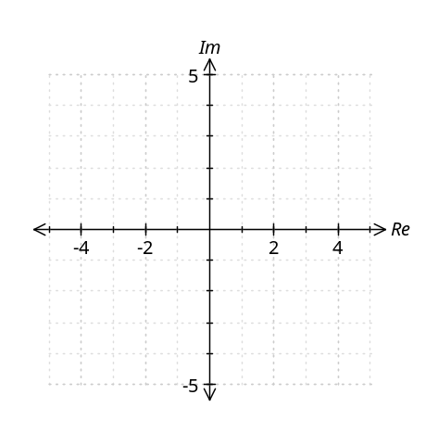
(b) On the diagram below, sketch the locus of the point z where ⎪z⎪ + ⎪⎪ = 8.
[2]
(c) On the diagram below, sketch the locus of the point z where arg (z) − arg () = 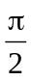
[2]
Question 13. [11 marks]

The temperature C, in degrees Celsius, of an object removed from an oven slowly decreases to a room temperature of 25°C. The rate at which the temperature decreases is proportional to the difference between the temperature of
the object and that of the surrounding environment at any given time t minutes.
After 9 minutes the temperature has dropped to 86°C and after 15 minutes it has dropped a further 10°C.

Express the temperature C as a function of time t, in minutes, and use your equation to determine by how much the object has cooled in the first 20 minutes.

Question 14. [6 marks]

Consider the curves represented by 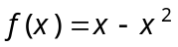 and 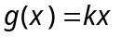, where k is a constant and x ≥ 0.
Given that the area bounded by 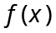 and is 4.5 square units, explain why this can only occur if 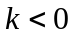 (a diagram may be useful). Determine the value of k that will give this area.

Question 15. [9 marks]

The side view of the right side of a coffee cup can be modelled by a piecewise function defined by 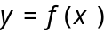 as follows:
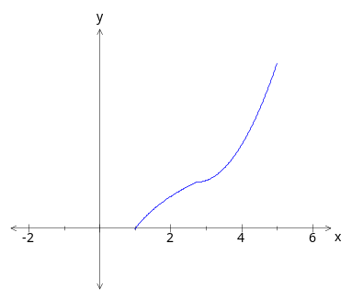

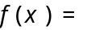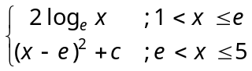

All measurements are in centimetres.

(a) Given that the function is continuous for 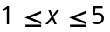, determine the value of c and find the height of the cup correct to 2 decimal places.
[3]

(b) The cup is formed when the region between and the y axis is rotated about the y axis.
Determine the volume of the coffee cup (assuming that the cup is totally full).
[6]

Question 16. [6 marks]

An object of weight W kg is pulled along a horizontal plane by a force applied to a rope that is attached to the object. The rope makes an angle of θ degrees with the horizontal. The magnitude of the force applied, in Newtons, is given by’

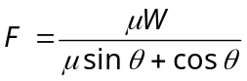 where μ is a constant called the coefficient of friction.

Suppose a man is pulling a 50 kg box along the floor, and that μ = 0.2. If θ is changed from 45° to 46°, use the Incremental formula to approximate the change in the force that must be applied.
Question 17. [5 marks]

The top of a silo is hemispherical in shape and has a diameter of 6 metres. It is coated uniformly with a layer of ice, and the thickness (W) of the ice is decreasing at a rate of 0.625 cm/h. Let the volume of ice coating the silo be V.
Show that 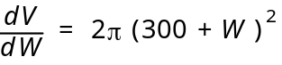 and hence determine the rate at which the volume of ice is decreasing when the ice is 5cm thick.
Question 18. [8 marks]

Consider the function, y = 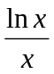 , for x > 0

(a) Use Calculus techniques to show that the only stationary point on the graph of this function occurs at ( e, ). Indicate this point on a sketch of the function.
[5]

(b) Hence, show that x e for x > 0
[3]

Question 19. [7 marks]

A curve has equation 4x² + y² = 4. Find, exactly, the maximum distance from the point
(1, 0) to this curve. Justify your answer.

Question 20. [13 marks]

A particle moves such that its position vector at time t seconds is given by

(a) On the axes below, draw a sketch of the path of the particle, clearly indicating its starting position and direction of motion.
[3]
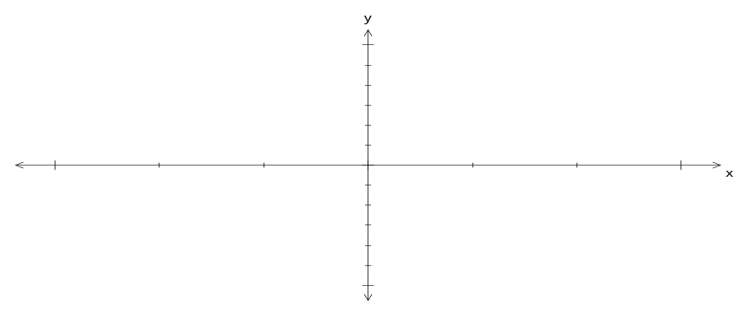

(b) How long does it take for the particle to return to its starting position?
[1]

(c) Determine the velocity and acceleration vectors 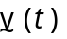 and 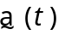 for the particle.
[2]

(d) At what times within a given cycle is the velocity of the particle perpendicular to its acceleration?
[3]

(e) Determine the minimum speed attained by the particle and the times at which this
occurs. Justify your answer mathematically.
[4]

Question 21. [14 marks]

Consider the three functions f (x) = 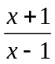, g (x) = 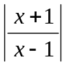, h (x) = 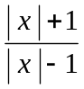 .

Write down the domain and range for each of the following,

 | Domain | Range
f (x)

f ⁻¹(x)

g (x)

h (x)

f [g (x)]

END OF EXAMINATION

EXTRA SPACE FOR WORKING
Please clearly number any questions you do here

STUDENT NUMBER:

In figures

QUESTION | MARKS AVAILABLE | YOUR MARK
1 | 6
2 | 10
3 | 4
4 | 6
5 | 9
6 | 13
7 | 8
8 | 9
9 | 15
10 | 7
11 | 8
12 | 6
13 | 11
14 | 6
15 | 9
16 | 6
17 | 5
18 | 8
19 | 7
20 | 13
21 | 14
TOTAL | 180

